Crawshawbooth Primary School
Handwriting Policy
September 2025
Mrs North

School Mission Statement

Crawshawbooth Primary School seeks to provide a happy and secure learning environment where a child’s natural curiosity is provided with challenges, experiences and opportunities that will enable them to grow into caring, confident and informed citizens of the future.

Rationale
At Crawshawbooth Primary School, we believe that developing clear, fluent, and legible handwriting is an essential skill that supports children’s confidence and success across the curriculum. Our handwriting policy is designed to ensure consistency in teaching, while promoting good posture and correct pencil grip.
Aims

- To have a consistent cursive approach across the infants and juniors to ensure high levels of presentation.
- To adopt a common approach towards handwriting by all adults when writing in children’s books, on the whiteboard or on displays / resources.
- Children to achieve a neat, legible style with correctly formed letters in cursive handwriting.
- Children to develop fluency and speed whilst writing, so that eventually the children are able to write the letters with confidence and correct orientation
Teaching and Learning
In EYFS, the Lancashire Red Rose letter formation phrase handwriting patters are introduced. This approach provides clear guidance on letter formation, size, and spacing, ensuring children develop an effective and efficient handwriting style.
It is recommended that when teaching letter formation, a phrase is used embed the directionality. All adults who teach letter formations are encouraged to use the same approach as children learn effectively through repetition.
The chart below provides the formation phrases linked to Red Rose Letters and Sounds which will be used in EYFS and the pre-cursive formation to be used from Year 1.

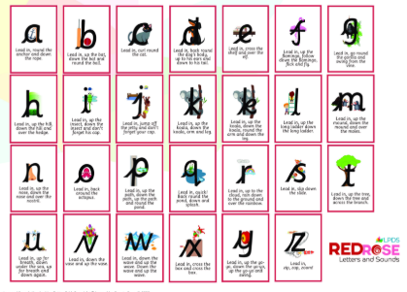
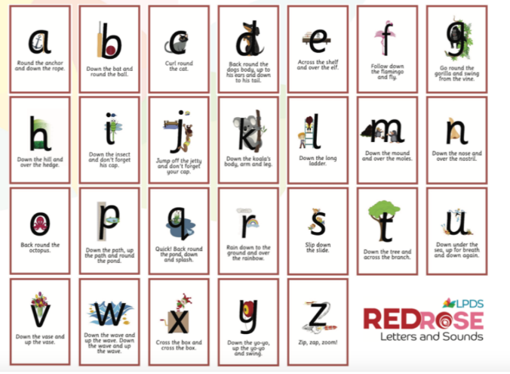

- Early Years Foundation Stage (EYFS): Communication, language and literacy
- EYFS will have daily handwriting sessions and will follow their own getting ready for writing and handwriting termly programme.
- Children to be introduced to pre-cursive and cursive script at the earliest stages of writing.
- Children in the Foundation Stage should be writing in the pre-cursive script to enable an easier transition in Year 1 into the cursive script, depending on their ability.
- Displays should include models of cursive script as well as printed script.
- Implements such as chunky triangular pencils, paint brushes, large chalks and chunky pens etc are used by pupils to rehearse skills on paper, chalk boards, pavement etc.
- Children should hold a pencil effectively in preparation for fluent writing- using the tripod grip for most writing
- Key Stage 1 & Key Stage 2
- Within KS1, every class will have daily 10 minute handwriting sessions per week.
- Within KS2, every class will have a specific handwriting session for at least two 15 minute sessions per week.
- In handwriting sessions, spellings, relevant key vocabulary or sentences/paragraphs related to core texts will be modelled by an adult then practised by children.

Children will be taught using the vocabulary of ascenders, descenders, loops, formation, spacing, size and join as they progress into KS2. Children will be taught using 4 types of joins.
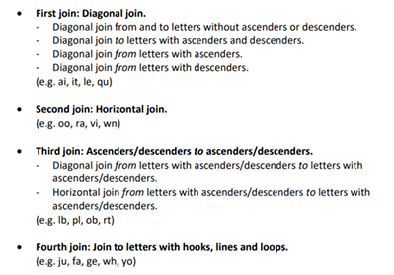
Posture for Handwriting
To support effective handwriting, children are encouraged to adopt a correct and comfortable posture:
- Sit up straight with both feet flat on the floor.
- Keep their back against the chair and shoulders relaxed.
- Place their non-writing hand on the page to steady the paper.
- Ensure the paper is positioned at a slight angle to support ease of writing.
- Chairs and desks should be correctly matched for children’s age and height.
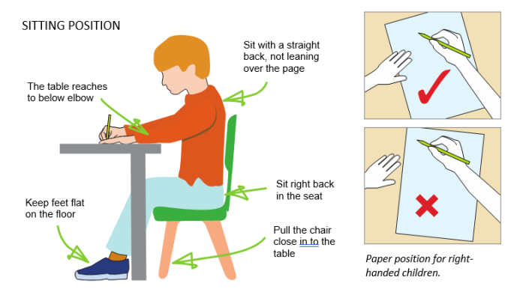

Tripod Pencil Grip
The tripod grip is taught and reinforced to ensure children hold their pencil correctly and write with control:
- The pencil is held between the thumb and index finger.
- The middle finger supports the pencil from below.
- The pencil rests comfortably between the fingers, allowing for smooth movement and control.
- Children who struggle with pencil grip will be supported with appropriate interventions and aids.
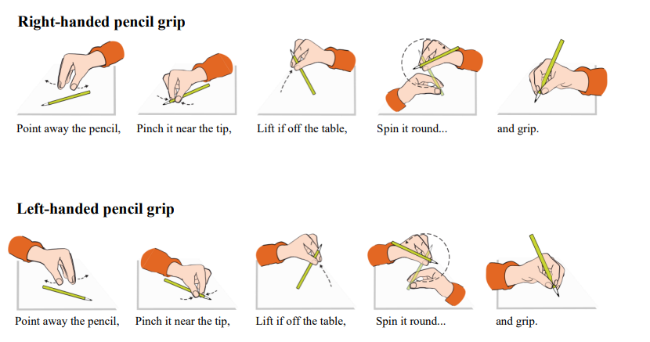

Implements

Children use a standard HB pencil, well sharpened. Children in EYFS to use the chunky style pencils as necessary. In the summer term of Year 2, children will be provided with a pen to use in their writing. They can continue to use a pencil if they feel more comfortable. Some children may be deemed as ready to have a pen at an earlier point. This is at the discretion of the class teacher. A pencil is always used in maths.

Planning

During handwriting sessions, children will apply taught formations to letters, words or parts of text relevant to their current learning. For example, they may practise the letters from their current phonics focus, the letter strings used in their weekly spellings, key vocabulary related to core texts or use parts of text from guided reading or literacy texts. Books will be used as evidence for the progression of handwriting. Handwriting sessions will begin with ‘4 P checks’- posture, pencil, paper, pressure. Activities to support the development of handwriting will also be provided. E.g. Hand and finger exercises, tracing over teacher’s writing, air tracing patterns and letters.

Use of ICT

Children who require more targeted support with letter formation have access to the Kaligo App as an intervention. Handwriting can be modelled via the writing repeater website on the IWB.

Equal opportunities and Special needs

All children must have the opportunity and the encouragement to reach their full potential regardless of race, creed or sex. Children with Special Educational needs, where necessary, will be provided with specialist equipment such as pencil grips or wider ruled lined paper. Children will also have the opportunity to use iPads to rehearse specific skills on a more regular basis. Intervention is available for children who experience significant difficulties to practice pre writing skills and fine motor coordination.

Assessment, Monitoring and Moderation
Children in the EYFS are assessed on an ongoing basis through observation, handwriting informs part of this. Within Key Stage One and Key Stage Two, handwriting is assessed as part of children’s writing assessments every term.

Homework
Children are encouraged to use the cursive script in all written home learning. Children may receive additional homework if needed and if appropriate.

Review

The policy was drawn up in March 2025. The policy will be reviewed and updated as necessary.
September 2025

