Guide for Parents/Carers
Booking Before & After School Club Sessions on SCOPAY
This guide will help you:
- View the club calendar
- Book sessions
- Cancel or change sessions

SECTION 1
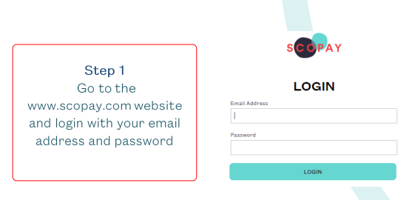
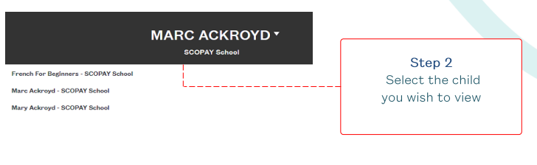

Important Information Before Booking
If you do not use an employee childcare voucher scheme or the government’s Tax-Free Childcare scheme to pay for wraparound care, you’ll need to credit your SCOPAY account in advance before you can book and confirm sessions. Please follow the instructions in Section 1 of this guide.
If you do use a voucher scheme or Tax-Free Childcare, you can skip ahead to Section 2.

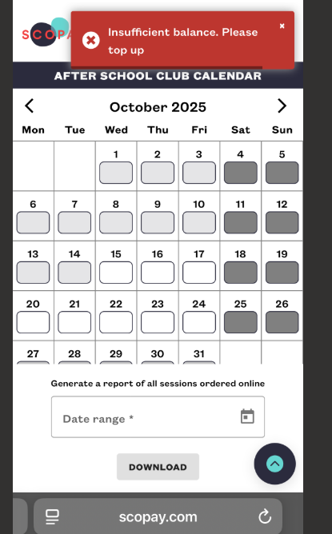
If your account hasn’t been credited in advance, a message will appear letting you know that payment is required before you can proceed with booking and confirming sessions.

Making a Payment in Advance
To book sessions, you’ll first need to add credit to your SCOPAY account.
- Click the green “Make Payment” button.
- You’ll be taken to a screen where you can enter the amount you wish to pay.
- Follow the steps to complete the payment process.
- Once the payment is successful, the amount will be added to your account.
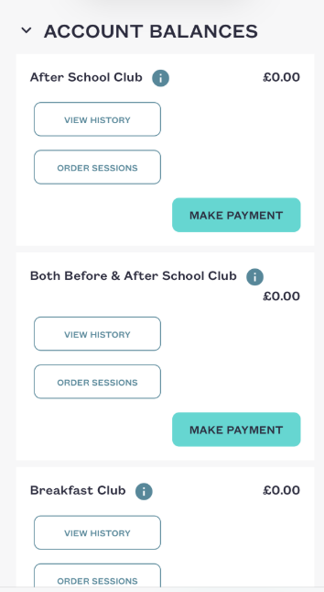
You’ll then be able to confirm your session choices, from the clubs available which are Breakfast Club (£6 per session), Both before & After School Club (£12.50 per session) & After School Club (£8 per session) and your credit balance will update accordingly

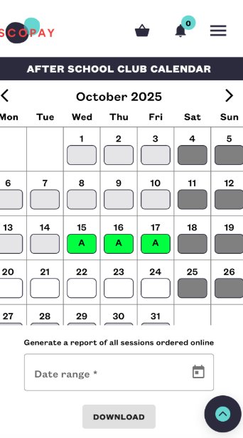
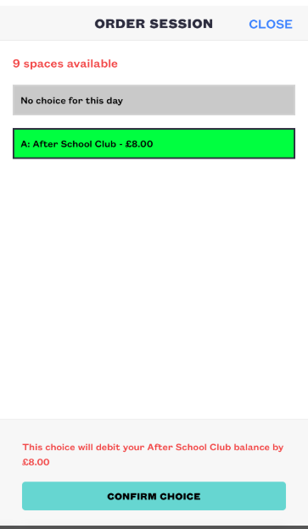

Section 2: Booking Sessions Using Childcare Vouchers or Tax-Free Childcare
If you are using an employee childcare voucher scheme or the government’s Tax-Free Childcare scheme, please ensure you have informed the school office. This allows us to configure your child’s SCOPAY account so you can book sessions without needing to make a payment in advance.

Booking Sessions
To book Before or After School Club sessions:
- Select the required club from the list of available options. Breakfast Club (£6 per session), Both before & After School Club (£12.50 per session) & After School Club (£8 per session)
- Choose “View History” to see any previous bookings, or “Order Sessions” to make a new booking.
- Select the desired date(s) from the calendar.
- Confirm your selection. Once confirmed, your booking will be automatically added to the club register.

No further action is required — your booking will be automatically added to the club register. You will be invoiced monthly, allowing you to arrange payment through your chosen childcare scheme

Section 3: How Do I Change or Cancel a Booking
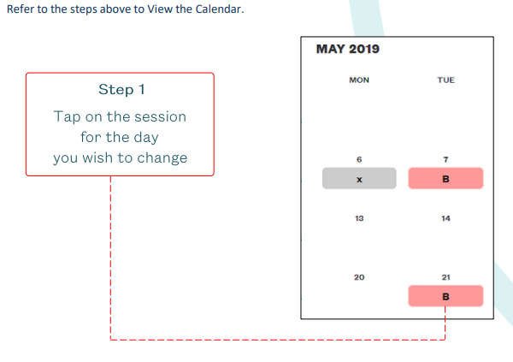
Click on Order Sessions or View Calendar – this will display the calendar.
Tap on the session for the date you wish to change.
Select your new session choice, or choose NO CHOICE to cancel the booking.

